EvNSW Technical Delegate & Organising Committee check list 2017

Event: | Date: | Completed By:

This document is intended to assist Technical Delegates and Organising Committees prior to the start of the competition and does not take the place of more formal requirements at FEI Events.

NSW Emergency Phone
Emergency | 000
NSW Rural Fire Service | 1800 679 737
Equestrian Australia Insurance Gow Gates | 1800 640 535
Gow Gates Equestrian Information | Website

TD check
Has the Organising Committee compiled a list of MOB phone contacts?

Has the MER file and Reverse MER file been received?
Previous Event documents (TD report, XC analysis) been received?
Safe Equestrian Poster. Information to be included -Nearest Hospital, Nearest Medical Centre, Local Police, Local Fire Station, Person responsible for Risk Management Click here
Gow Gates Serious Injury Report Click here EA Incident Report Click here
Gow Gates Event Inspection(Risk management) Click here

Gow Gates Club Induction Click here

EvNSW XC Fall Form Click here
FEI Fall form Click here
EvNSW General Fall Form Click here

It is the Organising Committees responsibility to ensure all the following are in place.

Organising Committee Check list | Notes | TD check
Venue map
Dressage arena check
DR Judges re Eventing rules (sent with acceptance)
XC – measurements, maps, distances, speeds & efforts
SJ maps and measurements
Paramedic booking times
Radios on charge – all days
Radio allocation
Jump Judges briefing presentation sent prior to event
DR sheet collection
SJ sheet collection
XC sheet collection
Program
Synchronise timing clocks
Allocate timing clocks (including1st & last jump)
Helicopter GPS coordinates
Venue address (include nearest cross road)
Serious Incident Management Plan (SIM)
DR radio channel
SJ radio channel
XC radio channel
Placement of deceased horse
Jump Judges brief at Event (who, where/when)
Entry list with riders contacts
Entry list with NOK (+ 2nd contact at venue)
Folder compilation
Horse ambulance (winch &/or ropes)
Spare gravel / mulch
Going (hard/soft) plan to manage
Riders notice board for rule reminders
FOLDERS/CLIP BOARDS
Dressage: Correct DR tests - including spares, List of starters or program, Eventing dressage notes, General fall form, Officials contact list, Travel reimbursement, Volunteer rewards

Show Jumping: Score sheets, List of starters or program, Show Jump annex, General fall form, Officials contact list, Travel reimbursement, Volunteer rewards

Cross Country Jump Judges & Sector controllers: Jump Judge guidelines or Jump Judge Presentation booklet, Basic Life Support (BLS) Jump Judge sheets, List of starters or program, Maps, XC Fall report Form (EvNSW or FEI), Volunteer rewards

Cross Country Marshal, Starter, Finish,: Officials contact list, Start/Finish sheets, List of starters with due start times, Maps, Incident/Fall reports, List of scratched, Eliminated W/Drawn riders from scoring database, Volunteer rewards

Cross Country Control: Officials contact list, List of starters with due start times, Maps, Eliminated W/Drawn riders from scoring database, Mail merged XC control sheets, some controllers also like XC Blank fence table from scoring database.

Paramedics, Doctors: Officials contact list, List of starters with due start times for each phase, XC maps, XC Fall report Form (EvNSW or FEI)

Vets and Stewards: Officials contact list, List of starters with Due start times for each phase, XC maps, XC Fall report Form (EvNSW or FEI)

Additional documents for FEI Events: Vet data sheets with FEI rego Nos, Microchip Nos.

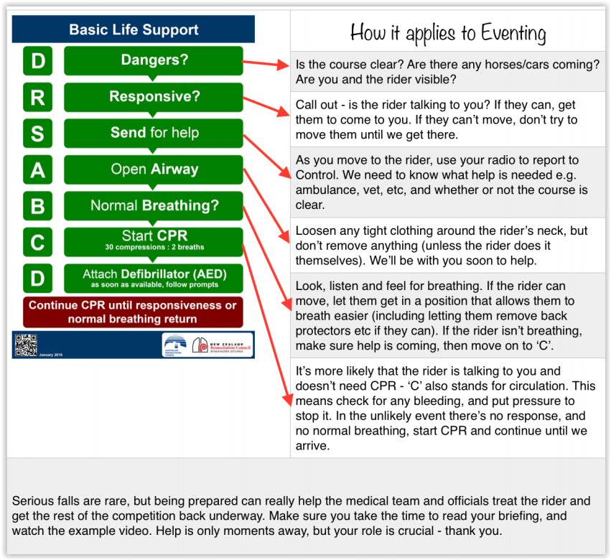
EvNSW SERIOUS INCIDENT MANAGEMENT (SIM)
This document does not take the place of FEI requirements. It is a brief outline of some procedures that should be considered prior to the start of the Event.

- A meeting should take place with officials before the start of the Cross Country

SIM Management Team | Name | Phone
Representative of the OC (Head of SIM)
Technical Delegate or their Representative
Medical Officer or their Representative
Veterinarian or their Representative
Press Officer/Communications
NOK contact/ family liaison
Assistant to assist with admin

Independent Investigation Panel | Name | Phone
Member 1 (Non officiating Official)
Member 2 (Non officiating Rider)
Member 3 (Person experienced in Eventing)

- In case of a serious accident of a rider or horse immediate action and communication will be:
At the fence:
- screens up while any treatment is taking place
- take rider or horse into ambulance as quickly as possible, subject to Medical/Veterinary advice to clear the course to continue the competition
- fence repair crew to repair ground or fence if necessary
- Fence judge to be replaced if necessary, as required to provide a report/independent statement. Fence judge may require support following a serious accident.
- PA Commentator to announce hold up on course, without further details
- Media and photographers at distance if possible
Meeting:
- Initiate gathering of information and establish facts, check if video material, photographs, diagrams statements with the help of the TD is available
- Inform essential contacts
- Keep contact with hospital
- Arrange communication / support with immediate issues with Riders family /team/friends / horse owners (accompany to hospital, provide info & logistical support)

Actions:
- Communication: holding statement to be provided to Media, Commentator
- Decide if event should continue if case of rider fatality (rider meeting can be convened before decision is taken)

Media Communication:
Written statements
- Name of rider, nationality
- Name of horse (owners)
- Type of fall:
- The organisers are investigating the facts surrounding the incident, Rider or horse is undergoing medical investigations. A full statement will be issued and a press conference held when more information as soon as possible / as available
Verbal statement: Rider or horse is undergoing medical investigations and that more information will be available as soon as possible / as available.
Press conference:
- If required start press conference after the end of the competition – allow time to gather necessary information.
- In case of fatality: a factual statement and only few questions to be authorized
- Secure relevant rider/horse biography
- If horse fatality, establish if rider is prepared is will/able to meet the press
- Prepare Press statement – see below
NB: Replies, written or verbal, should be:
- calm
- objective
- clear and factual
- brief
- responsible and concerned

Additional FEI information including FEI EVENTING SERIOUS INCIDENT MANAGEMENT (SIM) 2017 UPDATED December 2016 Click here

